## Creating a data structure for the Bashsoft

Our next task is to **create** a fast and **efficient data structure** that we can **use** in out command interpreter **to store** **data**, easily **make changes**, **find** wanted **information** or **generate** some **statistics** from the data.

**First** thing you have to do is to **open** your **project** from the previous assignment and **set** **up** a **class** in which you will store your data. You have to create **a new class**, following the steps from the previous piece of the story. This class will be called “**StudentsRepository**” and has to be **static** and **public**. By now you should be somewhere around here:

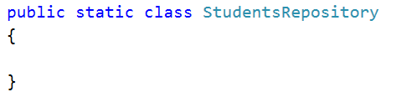

Now it is time to decide what **data structure** to define for our application in order to be able to make **fast operations** and have easy access to your data. Since we have to save different courses, the students in those courses have **unique** usernames and list of grades, we can save them in two nested dictionaries with one additional list. See below:

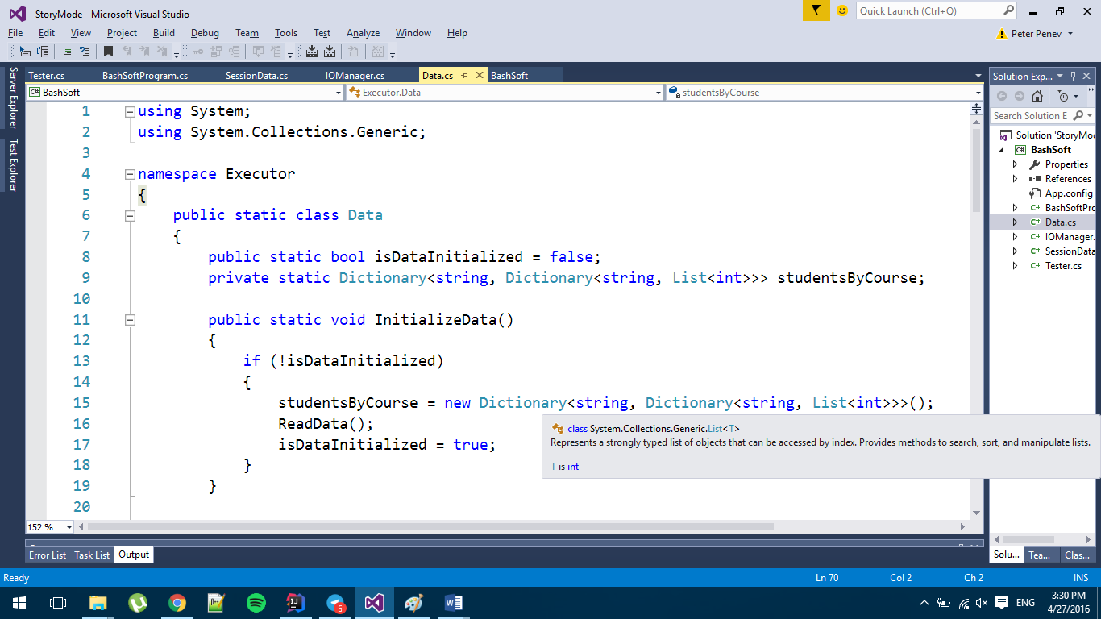 

We will also **add** a **public** **boolean flag** for **whether** the **data structure** we want to have **has been initialized**. You may have noticed but we’ve put **private** in front of our **data structure** and that is **because** we **do not want** **everybody** outside of this class **to see** our data structure and **change** it, **so** by making it **private** we can **only see** it in the **current** **class** and we will make some of the data **searching and filtration throughout public methods** that give to the other world the basic operations needed over the **SoftUni** system’s data.

## Initializing and saving our data

In order to complete our task, we need to **initialize** our **data structure** and **fill it**, so we will **make a new method** that **initializes** the **data structure,** **if it is not initialized yet**, **reads** the **data**, if it is, we **display** a **new** **message** called **DataAlreadyInitialisedException** that we need to **add** **first** **in** the **ExceptionMessages** **class**. It’s **message** **should** **be**: Data is already initialized! The implementation of the method for the initialization should look like this:

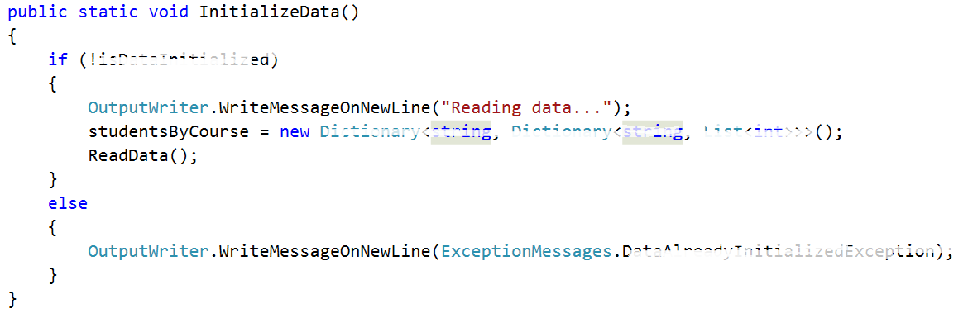

Now it’s time to **fill** the **private ReadData** method (the data will always be valid). It is **private** because we **do not want** to be reachable out of our class.

All we are going to do, is to **read from the console until an empty line is read**. The data you need to read is in the **data.txt** file given with the current document. We also need to **extract** the **information** we need **from** the **input** and **save** it **in** our **data structure.**

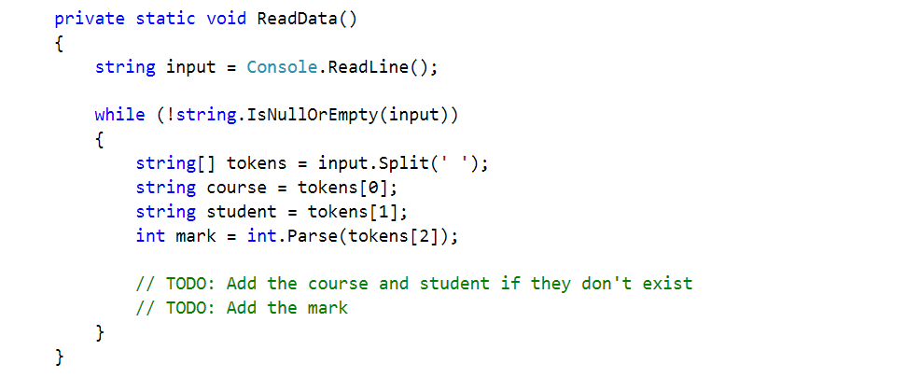

Now we need to **check** **if** our course and student **exists** in our data. **If** we **don’t do this** we are sure to get an **exception**. So **if** the **course** **doesn’t exist** we must **initialize the inner** **dictionary** holding the students for the given course. Also **if** the **student** **doesn’t** exist we have to **initialize the inner list** with grades. Finally we **add** the mark.

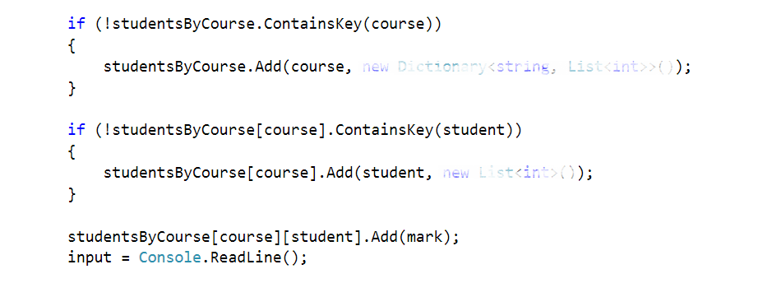

Finally **after** the **while** **loop** we need to **set** the **isDataInitialized** to **true** and **print** “**Data** **read**!” **on** a **new** **line**!  


## Making security checks available before retrieving data from the data structure

Since we are going to **make** **queries** **to** the **data** **structure** in this BashSoft piece and also in some others along the track of the course, so it **would** **be** a **good** **idea** **to** **make** a **method** **for** the **security** **checks** **in** **order** **to** **retrieve** some **data** for a given course or for a given student in some course. This way we will **save** **our** **selves** the **writing** of the **checks** **each** **time** and **invoke** the **methods** **where** such a check is **needed**.

So the **first** **method** will be **called** **IsQueryForCoursePossible** and the **second** will be **called** **IsQueryForStudentPossiblе**. **Both** should be **private** and **static** and as you might guess their **return** type is **bool**. The **first** one take **one** **parameter** (**the course name**) and the **second** one takes **two** **parameters** (**the course name**) (**the user name of the student**). Their definition should look like the following:



Since the **second** **method** will have to do half of the checks for the course that are done in the first method we **will** **reuse** the **first** **one** and for this reason we are starting with it’s implementation.

First thing we need to **check** in order to search for the given course name, is **whether** the **data** **structure** **is** actually **initialized**. **If** it **hasn’t** been **initialized** we **create** a **new** **message** **in** the **ExceptionsMessages** that is **called** **DataNotInitializedExceptionMessage** and it’s message is : “The data structure must be initialised first in order to make any operations with it.” :   
  
  
  
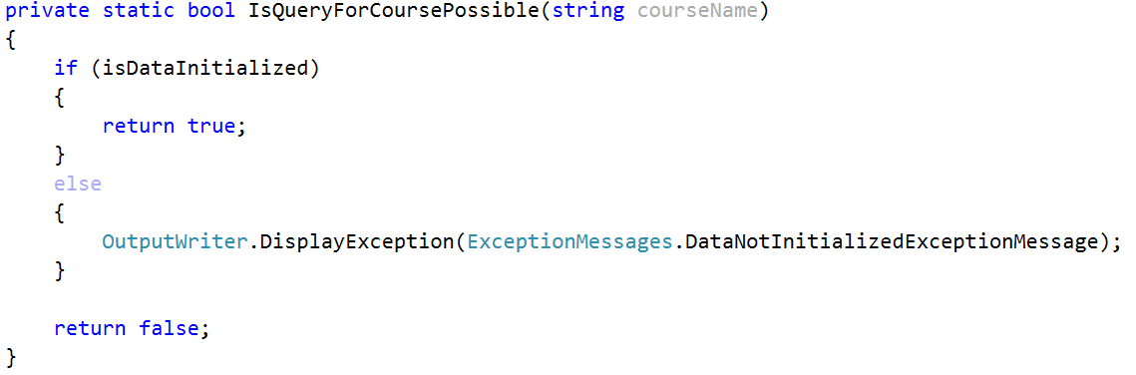  
We are now **returning** **true** **if** the **data** **structure** has been **initialized**, but we **haven’t** **checked** **whether** the **given** **courseName exists** as a key in the data structure.   
So now we have to **add** this **check** **in** the **body** **of** the **if** and **if** the **data** **structure** **contains** the **key**, we **return** **true** while in the **other** **case** we **display** an **exception** that we’ll need to add in the **ExceptionsMessages** called **InexistingCourseInDataBase** **with** the following **message**: “The course you are trying to get does not exist in the data base!”  
  
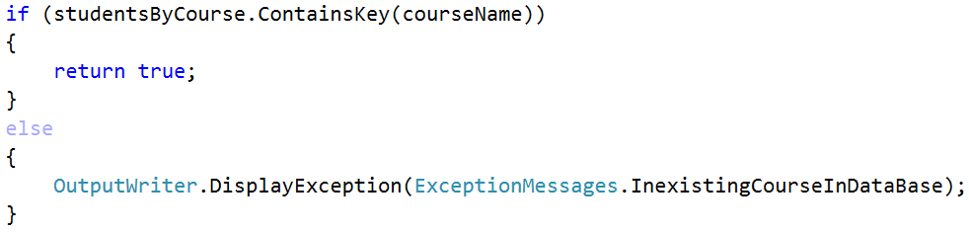  
Now that we’ve implemented the first method for the checks, it’s time for it’s sidekick. As we’ve said we will **reuse** the **check** **from** the **first** **method** and also **add** a **check** for **whether** the **given** student **user** **name** **exists** in the data structure of the university. If it is present, we return true, if it is not we **display** an **exception** that we’ll need to add in the **ExceptionsMessages** called **InexistingStudentInDataBase** **with** the following **message**: “The user name for the student you are trying to get does not exist!” and **finally** we **return** **false** :   
  
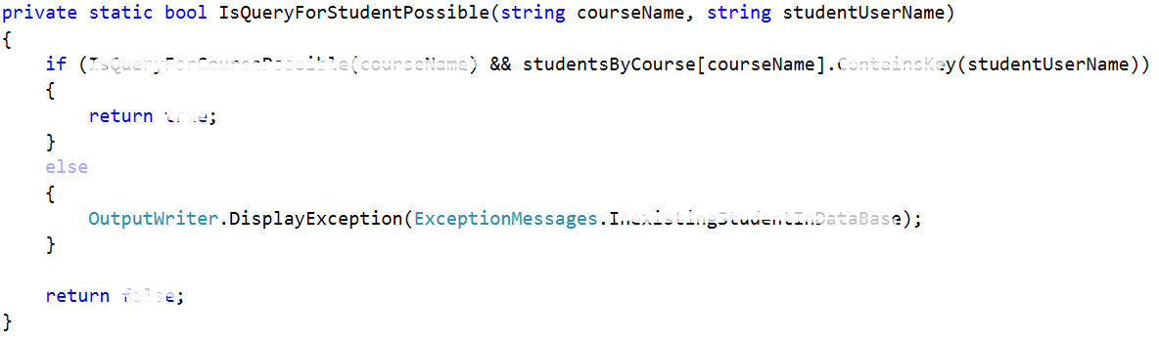  
Now that we are ready with the security checks we are ready to proceed with the next step.

## Displaying a student entry

**Before** we continue with the **reading** of the **data**, there is just one last thing we might **add** in order to make our life easier. Since now we have **two** **methods** that are going **to** **display** **student** somehow and we might have more things that need to display student after a filter or a sorting for example, by implementing such a method **we** **do** **not** **need** **to write formatting strings in every method** that displays students on the output writer. The given **method** will be **called** **DisplayStudent** **receiving** a **KeyValuePair** of **string** (user name) and value: **List<int>** (scores on tasks). A good place to **put** the **print** **student** **method** may be the Student repository, but maybe an even better place is **in** the **output** **writer** since it implements the logic for how thing are displayed on the standard output. The implementation of the method should be as follows:   
  
  
Now that we are ready with the displaying of a student are ready to proceed with the actual reading of the data from the data structure.

## Reading information from our data

The most basic operations for extracting information will be to **get all students from a given course** and **get all the scores on the tasks**. We need **define two methods**. Let’s start with the **first** **one**. It should be **public** **static** with **return** type **void**. It’s **parameters** are the **course** **name** and the **user** **name** **of** the **student**. So **if** the **query** **for** the **given** **student** is **possible**, we need to **print** the **him** **on** the output and so we give a new student to the **Output** **writer** in order to be printed:

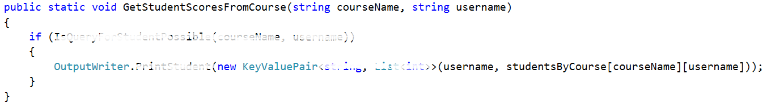

The other method is analogical. It **gets all students from a given course** **if** the **query** for course is **possible**.  
**First** we **write** the **course** **name** followed by two dots and after that we **foreach** the **collection** with **students** from the given course and **print** **all** of the **students**   
  
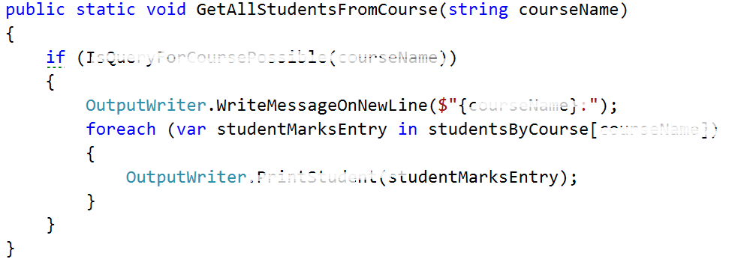

## Test your code

If you put the given input and **get all the students from the Unity course**( query should look like this): `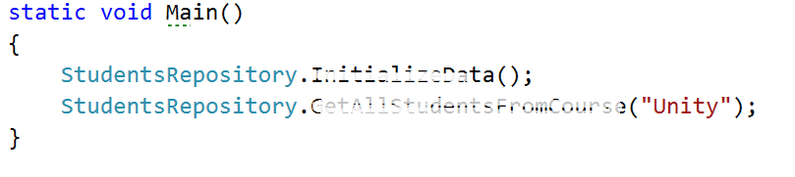

And the result should look like this:

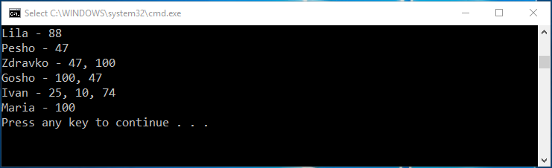

Now we want to test the functionality for **getting student’s grades from a given course**. The request should look something like this:

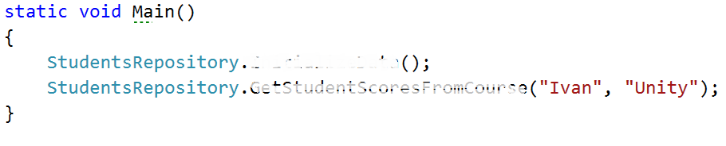

And the result, something like this:

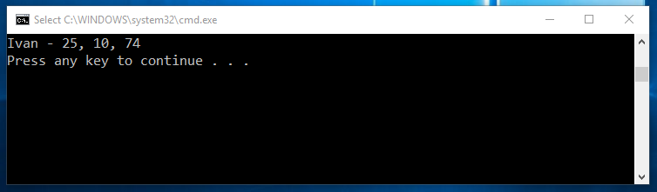

Now we are ready with the current piece and now we can easily keep track of the courses and students inside them and if needed, view some data that we might want. Soon we will **learn** how to make **filters** and **sort** our data so that it is in a more accurate format and moreover we will **go** **into** **depth** **about** the **constraints** for the possible course names, user names and scores on a given task.